All About Me!

Dear Parents/Carers,
Over the summer holidays it would be really helpful if you were able to complete our Parent Questionnaire to help us find out more about your child. It would also be great if you were able to make an ‘all about me’ shoebox with your child.
They can decorate it however they wish and include in it photographs, trinkets, pictures etc all about who they are, their family, what they enjoy and what things are special to them. We will then share these with the rest of the class in September and display them.
We have found this a great settling in activity as it gives the children chance to share them with their new friends and also have something which belongs to them, and which they are proud of, in their new classroom environment.
Yours Sincerely,

Kate Lambert
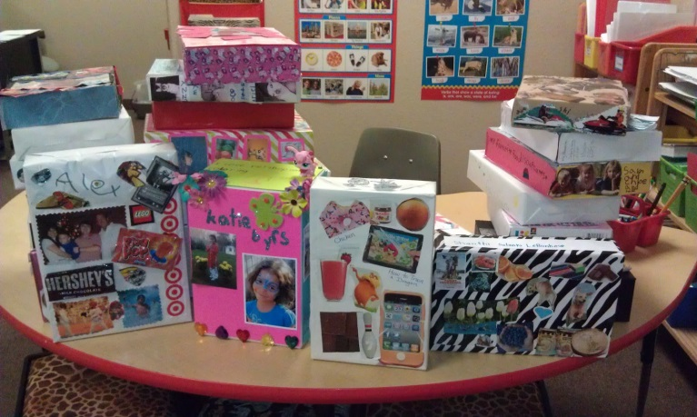
Headteacher

