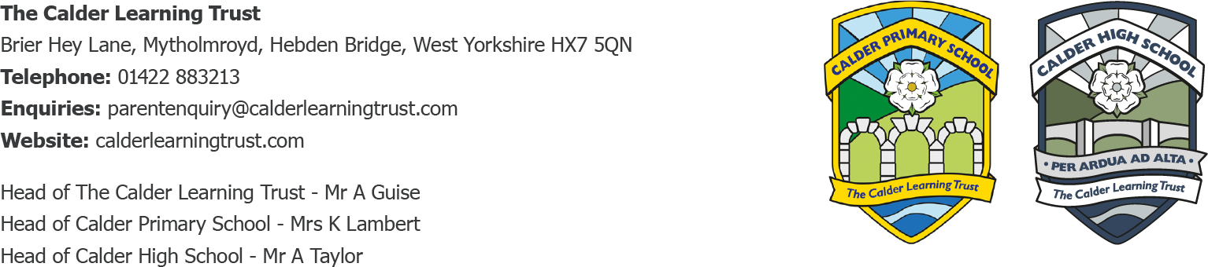

May 2024
Lights, Camera, Score
Dear Parents/Carers,
You might have heard from your child that they have been taking part in an exciting project with Calderdale Music Trust called ‘Lights Camera Score’, where they have been working with visiting musicians, musical instruments and technology to compose musical scores for a bespoke animated film. The project explores musical development, instruments, musical composition and how music relates to narrative and language. The musical scores completed by students are then recorded alongside student voiceovers to complete the audio visuals for the final film.
On Monday 10th June, they will spend the day at The Victoria Theatre with the other schools that have been taking part in the project.
A rough outline for their day:
9:30am – 10:30am Rehearsals
11:00am – 12:00pm Groups perform to each other
12pm – 1:15pm Lunch and screening of student films
1:45pm – 2:45pm Performance for the children from the English Chamber Orchestra
3pm Expected departure time

Year 4 will be accompanied by Mrs McVey (Calder Learning Trust music teacher) and Mrs Lambert on the day.
Please can they meet at Mytholmroyd train station at the car park side at XXXXXXX
They will need to wear their full school uniform and bring a coat, packed lunch and water bottle with them, ideally in a rucksack for easy carrying.
They will be catching the XXXXXXXXXX train back, please collect them from Mytholmroyd Train Station at XXXXXXXXXX

Yours Sincerely,

K.Lambert

Mrs K Lambert

Primary Headteacher

