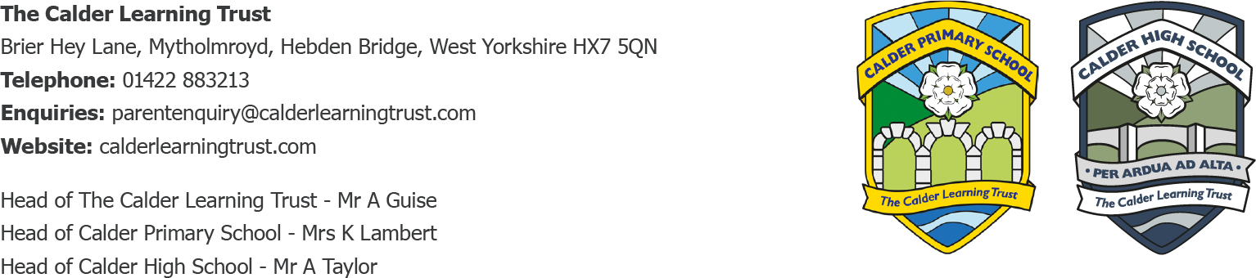
23.5.24

Residential: Useful Information
Dear Parents/Carers,
Some additional useful information for getting ready for Class 3’s upcoming Residential Trip to Robinwood.
- The teachers leading the trip are Miss Smith and Miss Appleyard, supported by Miss Gothard and Mrs Morris.
- Children can bring up to £15 spending money for the souvenir shop, if they would like to. Please send this in a named purse/wallet. They will be responsible for this, so if you pack it in an inner zip pocket for example, please make sure they know where it is
- Please do not pack any food/sweets/snacks/treats. This is a Robinwood rule and is really important that everyone follows it for children with allergies and medical needs. Children get great child-friendly meals and a selection of snacks throughout the day, so there is no need for anything additional.
- Please do not pack any electrical items which require plugging in or a charger e.g. mobile phones, smart watches, gaming devices, air pods, hair dryers. We would suggest avoiding electric toothbrushes for this reason, as they won’t be able to bring a charger. Pupils are also not allowed to bring any aerosol sprays due to the sensitive fire alarm systems.
- No cameras please, staff will take lots of photos of each group instead.
- We suggest all clothing items that are packed are old clothes and shoes that they don’t mind getting dirty or damaged. For this reason, we don’t recommend leavers’ hoodies as it is too sad if they get lost or damaged!
- Please name absolutely everything as there are often items left behind at tea, in showers, at different activities etc.
- It is best to pack light and avoid too many additional items from home to be responsible for, and the children are so busy from morning to night that there isn’t time for a full skincare routine! However of course they can bring a comfort item e.g. teddy from home if they would like to.
- Please bring all medication in a named bag/box and hand this in to Mrs Pickup or Miss Smith on the morning of Wednesday 5th June. Please ensure you have completed all the information for this on their personal information forms.
- Please bring your child to school for 8.45am as usual on Wednesday 5th June (or to breakfast club if applicable)
Please could you let us know:
- If you or another named collector are collecting your child from Mytholmroyd train station at 1:52pm on Friday 7th June or if they are walking home. Children can walk back to school with staff for a 3.15pm collection, however we would recommend someone collecting them from the train station if at all possible as they will be very tired by then!
Yours Sincerely, Mrs K.Lambert

