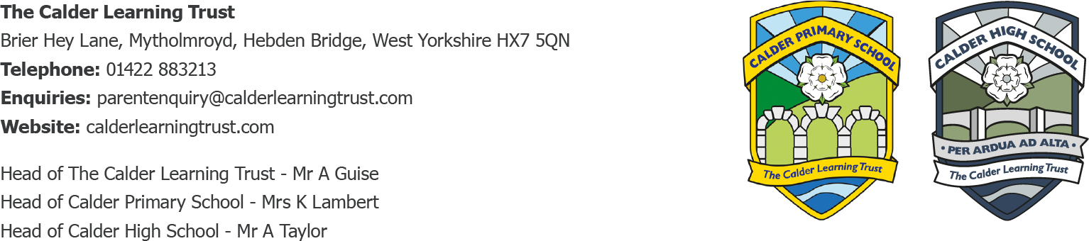

May 2024

Class 3 Residential, Wednesday 5 June-Friday 7 June

Dear Parent/Carer

Not too long now until Class 3’s residential trip to Robinwood Activity Centre in Todmorden.

Please find attached, another copy of the kit list for information.

We will be travelling to and from the Robinwood Centre by train and intend to catch the following trains:

Wednesday 5 June

Mytholmroyd to Todmorden – 11.07am

Children should come into school at the usual time that day and bring their luggage with them. They will have to carry their own bags to the train station so a case/bag with wheels would be a good idea, if you have one.

Friday 7 June

Todmorden to Mytholmroyd – 13.52

You may collect your child from Mytholmroyd train station at this time or from Calder Primary at 3.15pm.

We will be holding an information meeting on Thursday 23 May at 3.15pm for Class 3 pupils and parents/carers at which you will have the opportunity to ask any questions you might have.

Kind regards

Mrs K Lambert

Head Teacher

