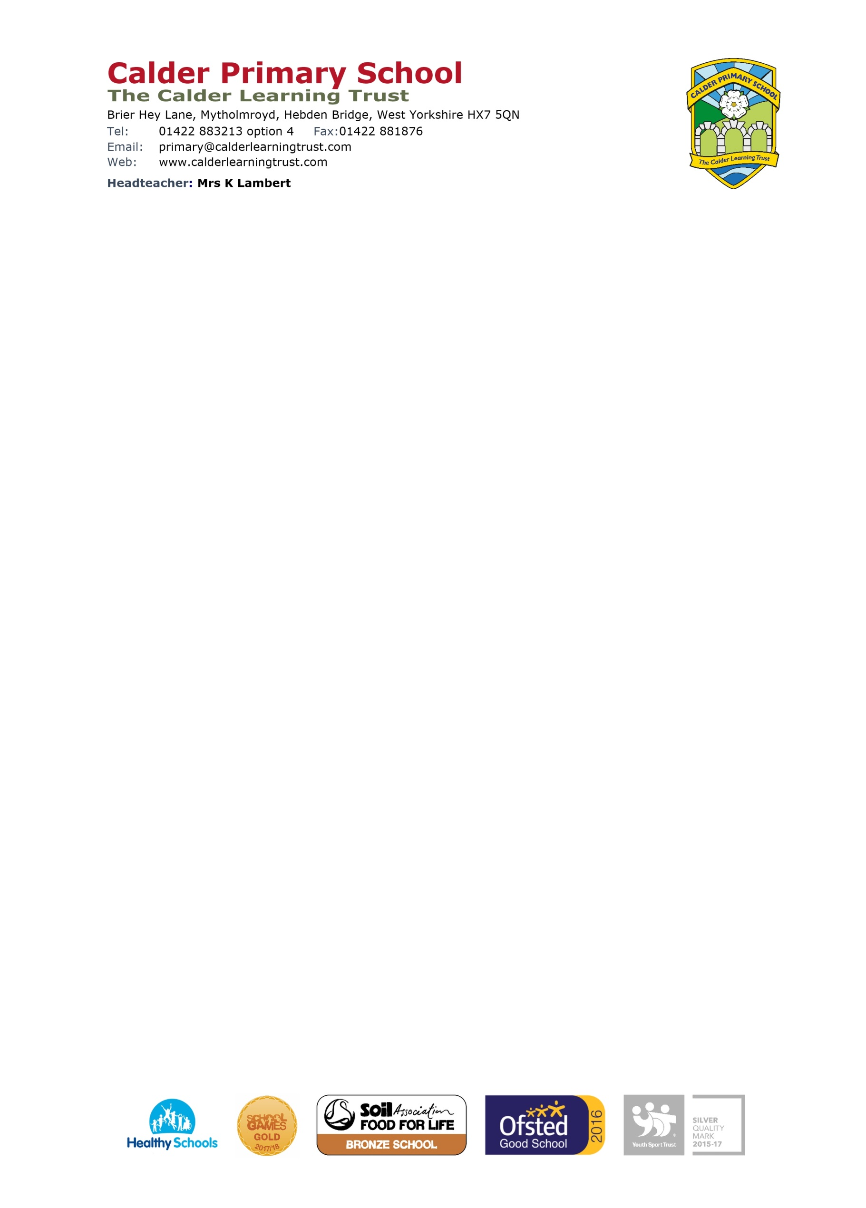

Dear Parents and Guardians,
This letter is to inform you about our use of Tapestry Online Learning Journal in our setting.
Tapestry allows us to make observations for your children where we can attach photos and videos, as well as include assessments which we can use to track children’s development and progress.
On Tapestry, parents/guardians and other relatives can view, like and comment on the observations we make for your child/ren. You can also add your own observations of what your child does outside of the setting which really helps us build up a picture of them and plan their learning.
We will also be using the accident form section to alert you to any accidents during the school day.
If you give your permission, we will set you up with your own individual account or accounts using your email address. This account will be directly linked to your child/ren’s account/s, which means you will only be able to see observations that include your child. You will then be able to login with your email address and password to either the browser version of Tapestry (tapestryjournal.com) or to the app. Tapestry has apps for iOS and Android. If you choose to use the app, after you login initially, you can use a 4-digit PIN to quickly log back in. There are parent user guides on our website under ‘Curriculum – EYFS’.
Tapestry securely stores all the data we input to our account on their servers. If you want to find out more information about how Tapestry keeps our data safe and secure, you just need to go to https://tapestry.info/security.html.
If you are happy to proceed, please fill in the slip below and return by email or paper copy. The account will be set up with the email address we hold for you already, please let us know if you would like us to use a different one or add an additional parent. Once you return this to us, we will then provide you with details about how to access and use your Tapestry account.
If you have any questions or queries about this, please get in touch.
Yours Sincerely.
Mrs K.Lambert

I give permission for a Tapestry account to be created for [name of child]:

The e-mail address/es I would like to link with the account is:

I give permission for a Tapestry account to be created for me (please sign and date):
Signature: Date:

