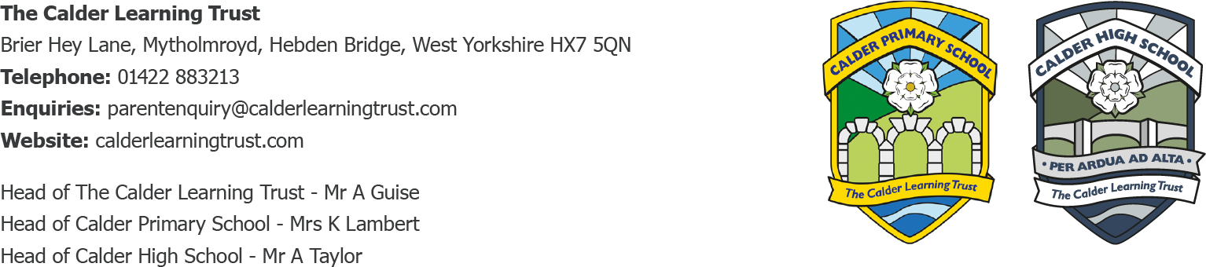

11.10.23
Extra-Curricular Clubs
Dear Parents/Carers,
We are writing to confirm the upcoming clubs on offer at school:
- KS2 Basketball Club – Mondays after school 3.15-4.15pm until October half term for Years 3-6.
- KS1 Dodgeball Club – Mondays after school 3.15-4.15pm from October half term to Christmas for Years 1 and 2.
- Class 3 musicians are welcome to join the Calder Learning Trust School Band – Monday mornings 8.15-8.50am in Calder High – ongoing throughout the year.
- Calder Primary Choir – Tuesday lunchtime for Years 2-6 (in Class 1) – ongoing throughout the year.
- School Newspaper Club – Wednesday lunchtimes for Years 4-6 (in the music room)
- Ukulele Club – Wednesday after school 3.15-4pm for Years 4-6 (in the music room) from Wednesday 18th October for 6 sessions until Wednesday 29th November.
- KS2 Construction Club – Thursdays after school 3.15-4.15pm for Years 3-6 (in Class 2) from Thursday 19th October for 6 sessions until Thursday 7th December (no session 26th October – Halloween Disco) .
There is no charge for lunchtime clubs, and these run for 25 minutes in order to allow children time for their lunch as well. The only clubs that have a charge are Monday Sports Clubs as these are with an external provider. Some clubs are limited on numbers, where demand exceeds this we will operate a waiting list and prioritise those children next time.
If your child would like to join ukulele club, construction club or KS1 Dodgeball Club, please complete the slip below or email Mrs Pickup to reserve your place.
If your child is in Class 3, plays an instrument and would like to join the band, please arrive at school by 8.05am on Mondays to walk across to the music rooms in Calder High.
We don’t have clubs for Reception during the autumn term as they are still getting used to busy days at school, but we do offer them later in the year.
We have some plans for different clubs after Christmas, but suggestions and contacts are always welcomed too! School Councillors have already brought ideas to their first meeting, but are always happy for more ideas too!
Yours Sincerely,
Mrs K.Lambert

Permission Slip
Club: _____________________________________________________
Child’s Name: ______________________________________________
I give permission for my child to attend
I will collect my child from Calder Primary main entrance at the end of the session
My child has permission to make their own way home at the end (Class 3 only)

