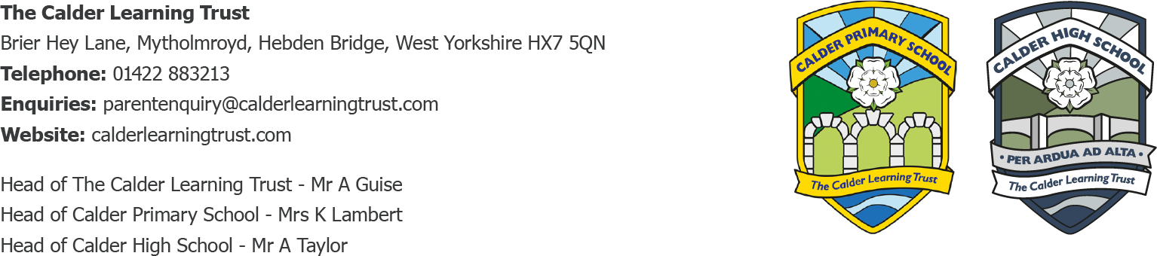August 2024

**Reception All About Me**

Dear Parents/Carers,

I hope you have all had a lovely summer so far.

I am excited to be teaching your child in September! To help everyone to get to know each other more, we would love it if your child could make an ‘all about me’ shoebox.

Please get a shoebox (or small box/container) and decorate it, perhaps in their favourite colours or with some stickers they like. They could include some items which tell us more about them – for example photos, drawings, a favourite character or book, a favourite hobby or a favourite food wrapper. They could also include anything they have enjoyed doing over the holidays. This makes a great ice-breaker and place to start the children talking about their own experiences, allowing both myself and their new classmates to find out more about them!

Please bring this on their first day in September and we will keep them safe and discuss a couple of boxes each day. This project also links nicely with our first class topic ‘Marvellous Me’.

Alongside this, we would love it if the children could bring in a photo of themselves and their family so we can display them in our home corner. This helps our children feel settled quicker and makes our home corner more believable and fun in our classroom provision.

A reminder that Calder Primary begins on **Wednesday 4th September 2024 at 8.45am.** Please line up by the infant playground gate (where you came for transition sessions) until the gate is opened. In most cases, a quick cuddle and cheery goodbye helps pupils to go into class smoothly, rather than staying too long. But we will help anyone who needs extra help with settling in too.

Please can children bring a water bottle, spare clothes and a coat - all named please! Please bring a sun hat if it is sunny. PE kits and wellies can be left on/by pegs as well so that we always have them in school.

We hope you have a lovely last few weeks of the summer and look forward to seeing you soon! If you have any questions, please do email us primary@calderlearningtrust.com

Yours Sincerely,

*Miss Appleyard*

Reception Class Teacher